CN -Lab 2
24k-0810

Bus Topology:

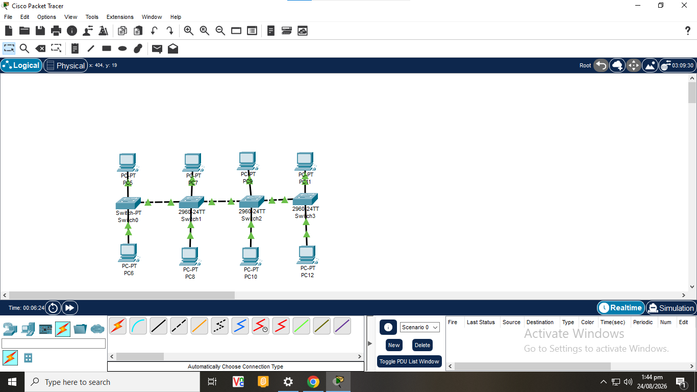

Hybrid Topology:
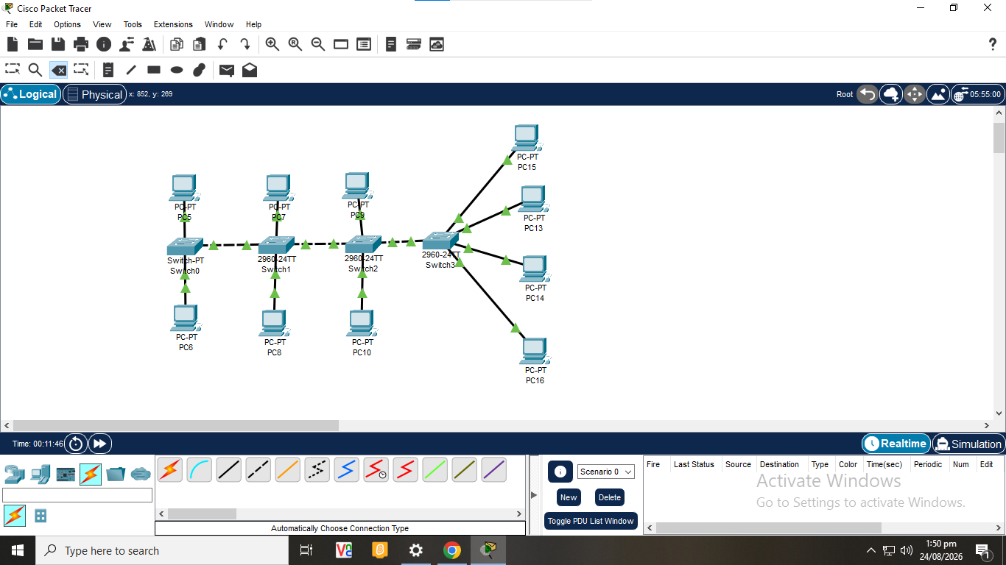

Mesh Topology:
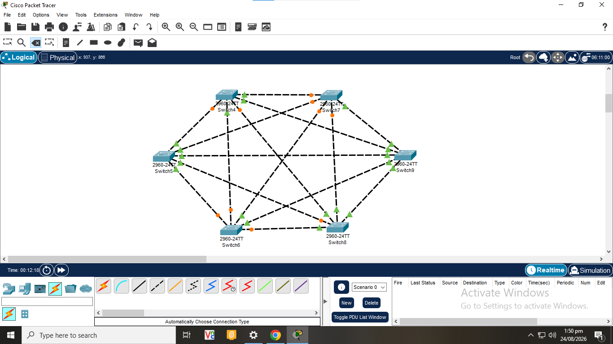

DHCP:
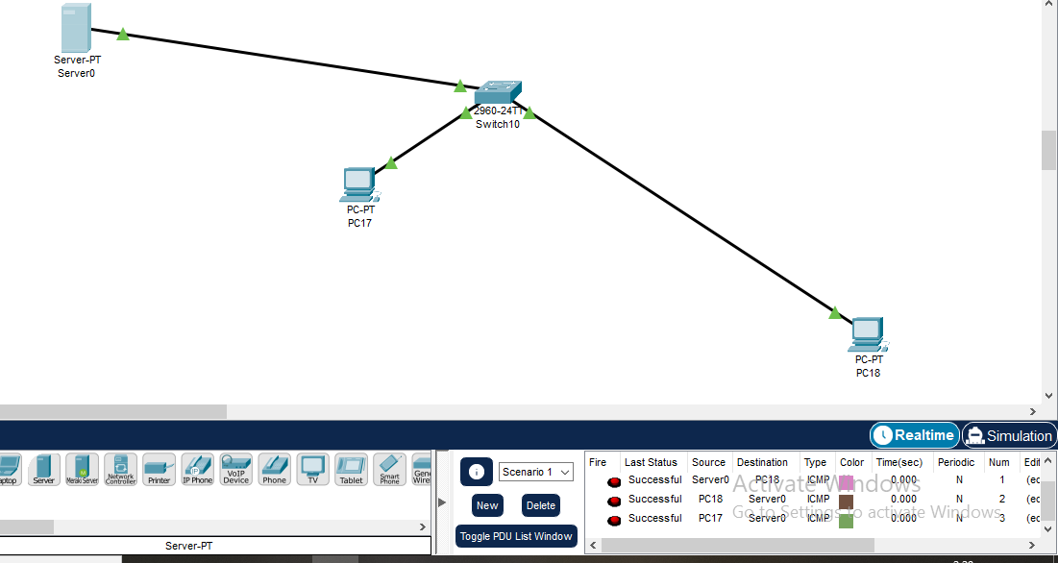

TASKS:

1. In Cisco Packet Tracer, create a small LAN containing four PCs and one switch. Connect all PCs to different FastEthernet ports of the switch using appropriate Ethernet connections. Configure each PC with a unique IPv4 address from the same network, using 192.168.20.0/24 as the network. After completing the configuration, verify the link status of all connections and test communication between at least two PCs using a suitable Packet Tracer connectivity-testing method. Record the IP configuration of the communicating PCs and explain how you confirmed that the LAN is working correctly.

Ping was used to test communication between PC0 and all other PCs, such as 192.168.20.2. Every packet sent was received during the successful ping; no packets were lost.
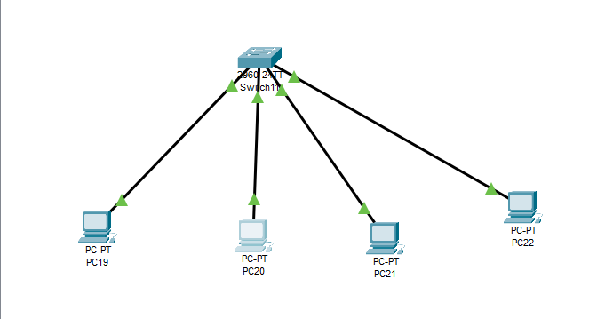

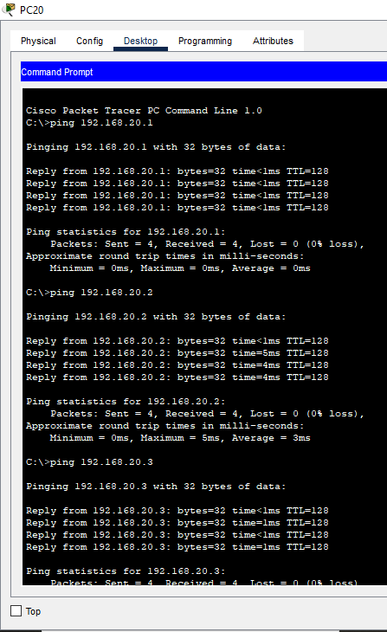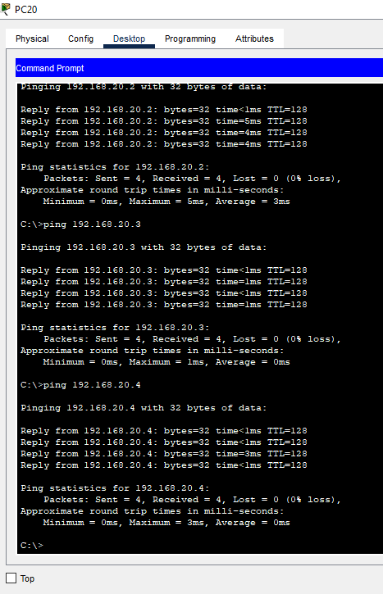

2. Design a network in Cisco Packet Tracer containing three PCs and one hub. Connect every PC to the hub and assign appropriate IPv4 addresses so that the devices can communicate within the same network. Test communication between two different pairs of PCs and observe the behavior of the network while sending the test packets. Based on your observations in Packet Tracer, describe what happens to the communication when a packet is sent from one PC to another through the hub.

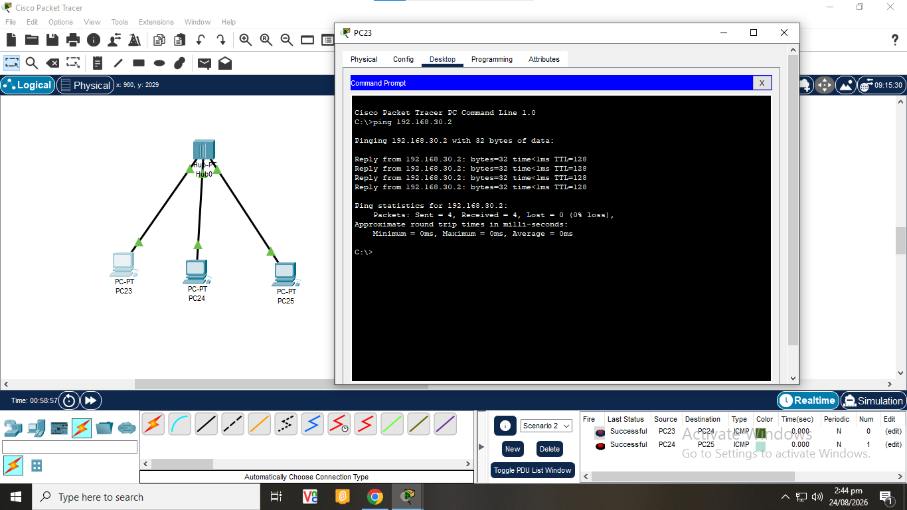
A destination port is not chosen by the hub itself. The hub notifies every port when it receives a packet. For example, a signal is transmitted to PC24 when PC23 transmits a packet to PC25. PC2 ignores the packet since it is not addressed to PC24, but PC25 accepts it since it is the intended destination.

3. In Cisco Packet Tracer, build a topology containing one hub and one switch, with two PCs connected to the hub and two PCs connected to the switch. Configure valid IP addresses for all four PCs. Your task is to connect the hub and switch so that communication can take place between a PC connected to the hub and a PC connected to the switch. Select an appropriate cable and suitable ports, then test the connection using Packet Tracer. If the link does not immediately become active, observe its status for some time and explain what you notice before testing connectivity.
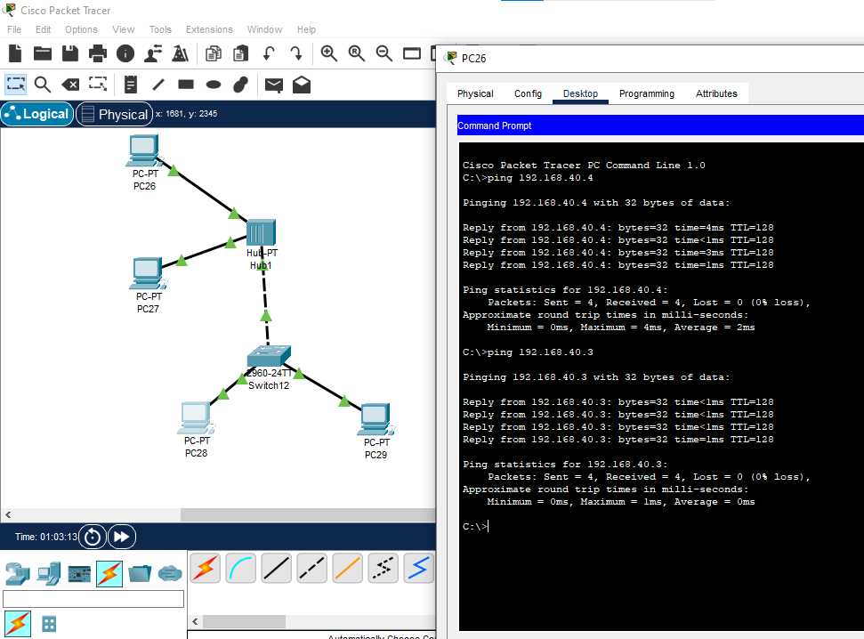

A copper crossover cable was used to link the hub and switch. The link indicator was orange at first, but it turned green once the network devices had finished initializing. Communication between the hub-connected and switch-connected networks was verified by a successful ping from one PC to another.

4. Create a network in Cisco Packet Tracer containing three PCs connected to a switch. Configure two PCs with addresses belonging to the same network, but intentionally configure the third PC with an address that places it in a different network. Attempt communication between the PCs and observe the results. After identifying the problematic configuration, modify the necessary network settings and repeat the connectivity test. In your answer, identify which configuration caused the problem and explain how the Packet Tracer test helped you locate the issue.
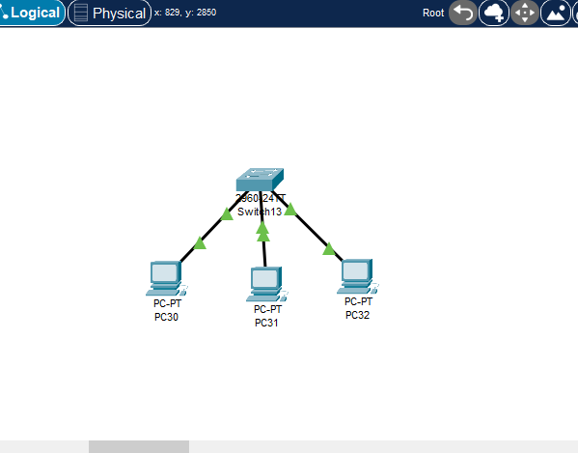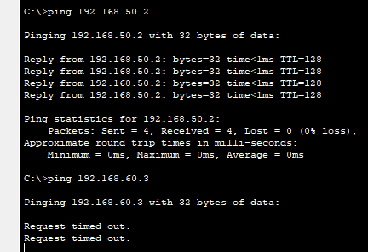
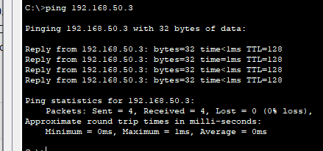
PC30 and PC31 were part of the 192.168.50.0/24 network, but PC32 was originally set up with the IP address 192.168.60.3 (60 network). PC30 and PC32 were unable to communicate. The ping was successful once PC32's address was changed to 192.168.50.3. This proved that the issue was caused by an inaccurate IP network configuration.

5. In Cisco Packet Tracer, create a network containing one server, one switch, and four PCs. Configure the server with a suitable static IPv4 address and configure it to provide dynamic IP configuration for the PCs. Set all four PCs to obtain their network configuration automatically instead of manually entering individual addresses. After the PCs receive their configurations, inspect the IP information of each PC and record the assigned IPv4 address and subnet mask. Test communication between two automatically configured PCs and explain how you verified that the DHCP-based configuration was working successfully.
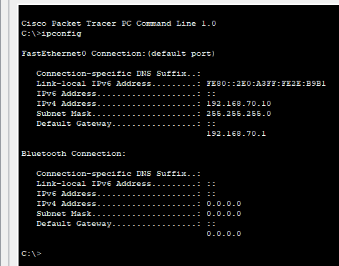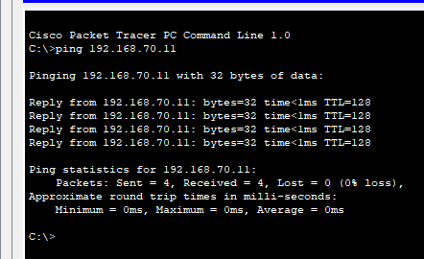
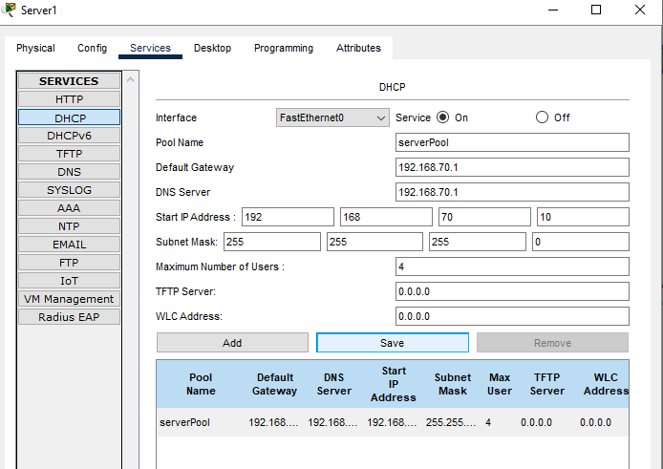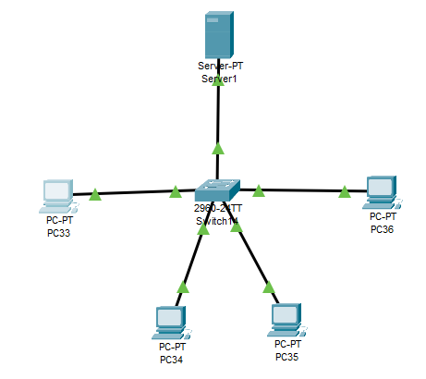

The static IP address 192.168.70.1 was set up for the DHCP server. The four PCs were set up to automatically get their IP settings. The DHCP pool assigned a distinct address to every PC. A successful ping between two automatically configured PCs demonstrated that the DHCP-based LAN was operating properly, and the IP configuration was confirmed using ipconfig.

6. Using Cisco Packet Tracer, create three small networks representing star, and mesh topologies. Use suitable network devices and end devices to demonstrate the basic structure of each topology. For each topology, identify how the devices are interconnected and perform a simple connectivity test where possible. Observe the number and arrangement of connections required in each design. Finally, compare the three topologies based on their physical structure, number of connections, and how a communication path is established between devices.
(a)
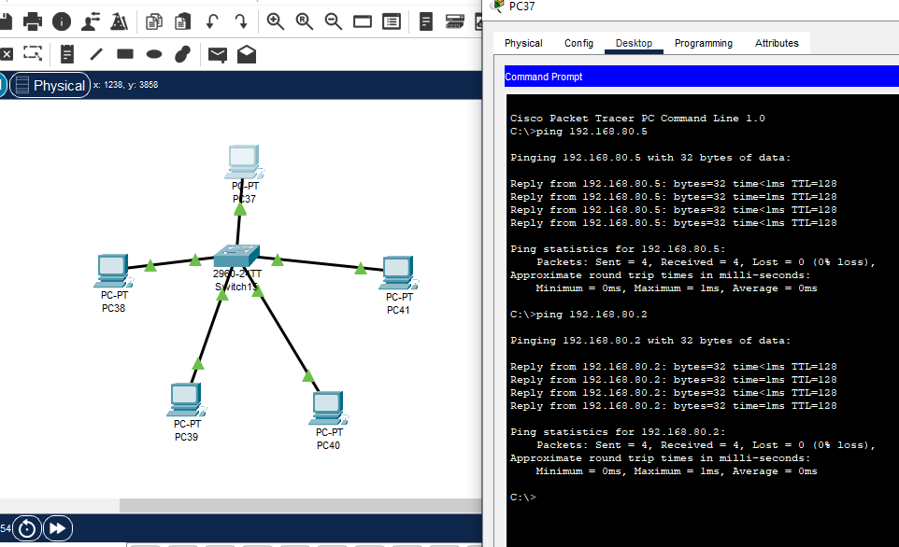

(b)
